* 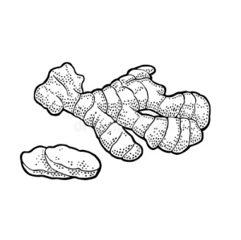चित्र देखकर वाक्य लिखो **| c.w**

--------------------------------------------------------------------------------------------------------------------------------------------------------------------------------------------------------------------------------------------------------------------------------------------------------------------------------------------------------------------------------------------------------------------------------------------------------------------------------------------------------------------------------------------------------------------------------------------------------------------------------------------

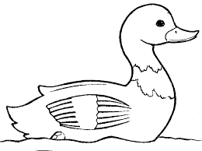

--------------------------------------------------------------------------------------------------------------------------------------------------------------------------------------------------------------------------------------------------------------------------------------------------------------------------------------------------------------------------------------------------------------------------------------------------------------------------------------------------------------------------------------------------------------------------------------------------------------------------------------------------------------------



--------------------------------------------------------------------------------------------------------------------------------------------------------------------------------------------------------------------------------------------------------------------------------------------------------------------------------------------------------------------------------------------------------------------------------------------------------------------------------------------------------------------------------------------------------------------------------------------------------------------------------------------------------------------



--------------------------------------------------------------------------------------------------------------------------------------------------------------------------------------------------------------------------------------------------------------------------------------------------------------------------------------------------------------------------------------------------------------------------------------------------------------------------------------------------------------------------------------------------------------------------------------------------------------------------------------------------------------------

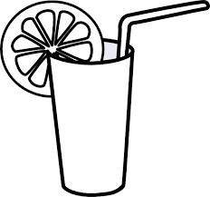

--------------------------------------------------------------------------------------------------------------------------------------------------------------------------------------------------------------------------------------------------------------------------------------------------------------------------------------------------------------------------------------------------------------------------------------------------------------------------------------------------------------------------------------------------------------------------------------------------------------------------------------------------------------------

चित्र देखकर वाक्य लिखो | **H.W**

